Section B — Practical Coding Tasks

Task 1: Design and Populate a Restaurant Database Create a structured schema for a food delivery system and populate it with sample data using DDL and DML commands. Create a database named foodapp_db and a table named restaurants with columns: restaurant_id (INT, AUTO_INCREMENT, PRIMARY KEY), name (VARCHAR, NOT NULL), city (VARCHAR), cuisine_type (VARCHAR), and rating (DECIMAL(3,1)). Insert at least 6 restaurant records spanning at least 3 different cities. Update the rating of one restaurant and delete one restaurant record using a WHERE condition. Write a SELECT query that retrieves all restaurants sorted by rating in descending order.
Answer:

CREATE TABLE restaurants (
restaurant_id INT AUTO_INCREMENT PRIMARY KEY,
name VARCHAR(100) NOT NULL,
city VARCHAR(100),
cuisine_type VARCHAR(100),
rating DECIMAL(3,1)
);
INSERT INTO restaurants
(name, city, cuisine_type, rating)
VALUES
('Pizza Hut', 'Surat', 'Italian', 4.2),
('Bhagyoday', 'Surat', 'Indian', 4.5),
('Burger King', 'Ahmedabad', 'Fast Food', 4.1),
('Dominos', 'Vapi', 'Italian', 4.3),
('Honest Restaurant', 'Surat', 'Indian', 4.2),
('Subway', 'Kanpur', 'Fast Food', 4.2);

UPDATE restaurants
SET rating = 4.8
WHERE restaurant_id = 2;

DELETE FROM restaurants
WHERE restaurant_id = 6;

SELECT *
FROM restaurants
ORDER BY rating DESC;

Output:

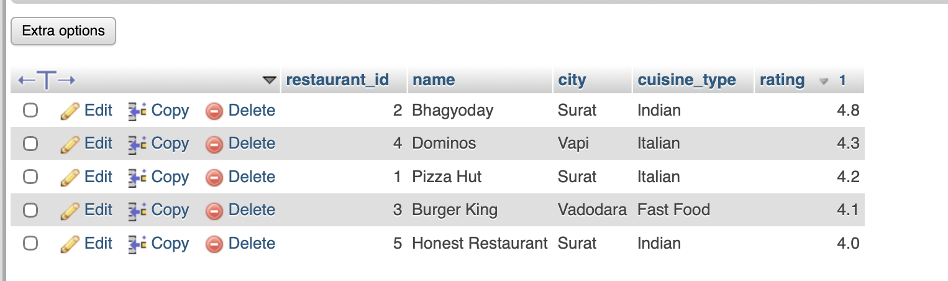

Task 2: Aggregate Revenue Reporting on Orders Write SELECT queries using aggregate functions and GROUP BY to produce a restaurant-level revenue summary from order data. Create an orders table with columns: order_id, restaurant_id, customer_name, total_amount, and order_date. Insert at least 12 orders distributed across at least 4 restaurants. Write a query to show total revenue and average order value per restaurant. Write a query using HAVING to list only restaurants whose total revenue exceeds Rs 5,000. Write a query to retrieve the 5 most recent orders using ORDER BY and LIMIT.

Answer:

CREATE TABLE orders (
order_id INT AUTO_INCREMENT PRIMARY KEY,
restaurant_id INT,
customer_name VARCHAR(100) NOT NULL,
total_amount DECIMAL(10,2),
order_date DATE
);
INSERT INTO orders
(restaurant_id, customer_name, total_amount, order_date)
VALUES
(1, 'Sanjna', 500.00, '2026-10-15'),
(2, 'Neha', 400.00, '2026-10-02'),
(3, 'Jay', 320.00, '2026-10-03'),
(4, 'Yash', 550.00, '2026-10-04'),
(1, 'Mona', 700.00, '2026-10-05'),
(2, 'Dipti', 280.00, '2026-10-06'),
(3, 'Sonu', 400.00, '2026-10-07'),
(4, 'Karishma', 850.00, '2026-10-08'),
(1, 'Nitya', 350.00, '2026-10-09'),
(2, 'Shikha', 500.00, '2026-10-10'),
(3, 'Shivani', 600.00, '2026-10-11'),
(4, 'Anjali', 750.00, '2026-10-12');

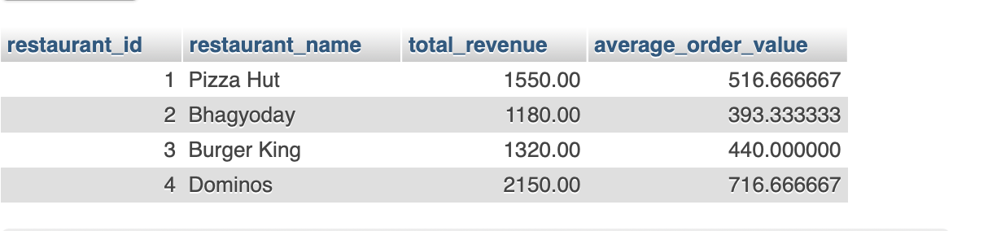 SELECT
r.restaurant_id,
r.name AS restaurant_name,
SUM(o.total_amount) AS total_revenue
FROM restaurants r
INNER JOIN orders o
ON r.restaurant_id = o.restaurant_id
GROUP BY r.restaurant_id, r.name
HAVING SUM(o.total_amount) > 5000;

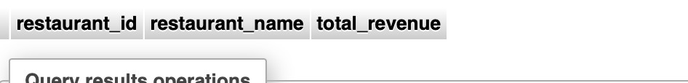

SELECT *
FROM orders
ORDER BY order_date DESC
LIMIT 5;
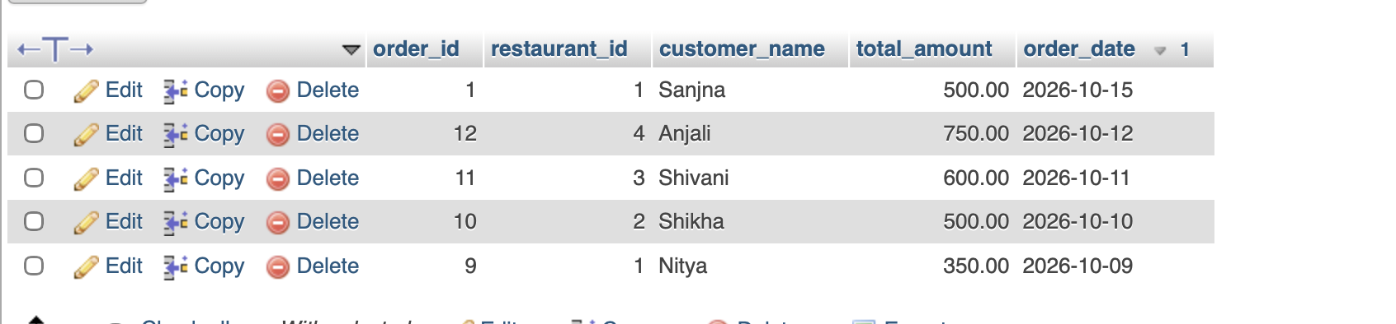

Task 3: Multi-Table JOINs and Menu Summary View Build a two-table schema for restaurants and menu items, write JOIN queries to combine data, and create a summary VIEW. Create two tables: restaurants (restaurant_id, name, city) and menu_items (item_id, restaurant_id, item_name, price, category). Link them with a FOREIGN KEY on restaurant_id. Insert at least 5 restaurants and 12 menu items; at least one restaurant must have no menu items. Write an INNER JOIN query listing restaurant name, item name, and price for all available items. Write a LEFT JOIN query so that restaurants with no items also appear in results, with NULL values in item columns. Create a VIEW named restaurant_menu_summary showing restaurant name, total number of menu items, and average item price grouped by restaurant.

Answer:

CREATE TABLE menu_items (
item_id INT PRIMARY KEY,
restaurant_id INT,
item_name VARCHAR(100),
price DECIMAL(10,2),
category VARCHAR(50),
FOREIGN KEY (restaurant_id)
REFERENCES restaurants(restaurant_id)
);

INSERT INTO menu_items
(item_id, restaurant_id, item_name, price, category)
VALUES
(1, 1, 'Margherita Pizza', 250.00, 'Pizza'),
(2, 1, 'Seven Cheesy Pizza', 350.00, 'Pizza'),
(3, 1, 'Paneer Chilli', 120.00, 'Starter'),
(4, 2, 'Paneer Tikka', 220.00, 'Starter'),
(5, 2, 'Veg Biryani', 180.00, 'Main Course'),
(6, 2, 'Butter Naan', 40.00, 'Bread'),
(7, 3, 'Veg Burger', 150.00, 'Burger'),
(8, 3, 'French Fries', 100.00, 'Starter'),
(9, 3, 'Cheese Burger', 200.00, 'Burger'),
(10, 4, 'Cheese Pizza', 280.00, 'Pizza'),
(11, 4, 'Pasta', 190.00, 'Main Course'),
(12, 4, 'Cold Drink', 60.00, 'Beverage');
SELECT
r.restaurant_id,
r.name AS restaurant_name,
r.city,
m.item_name,
m.price,
m.category
FROM restaurants r
LEFT JOIN menu_items m
ON r.restaurant_id = m.restaurant_id;

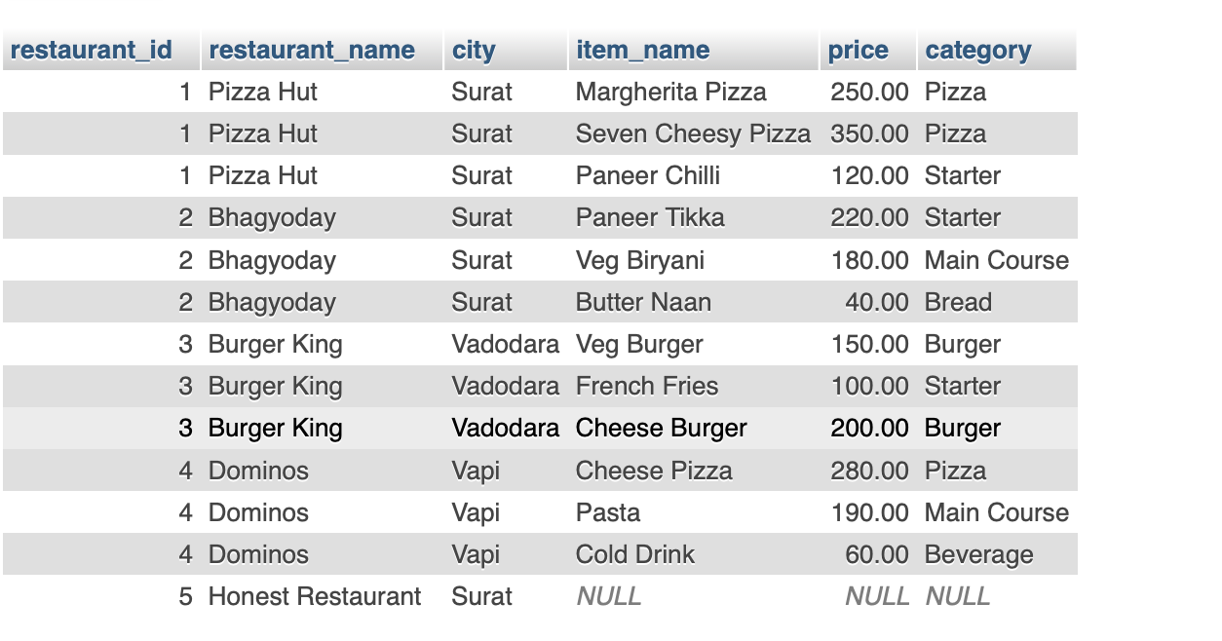

SELECT
restaurants.name AS restaurant_name,
menu_items.item_name,
menu_items.price
FROM restaurants

INNER JOIN menu_items
ON restaurants.restaurant_id = menu_items.restaurant_id;

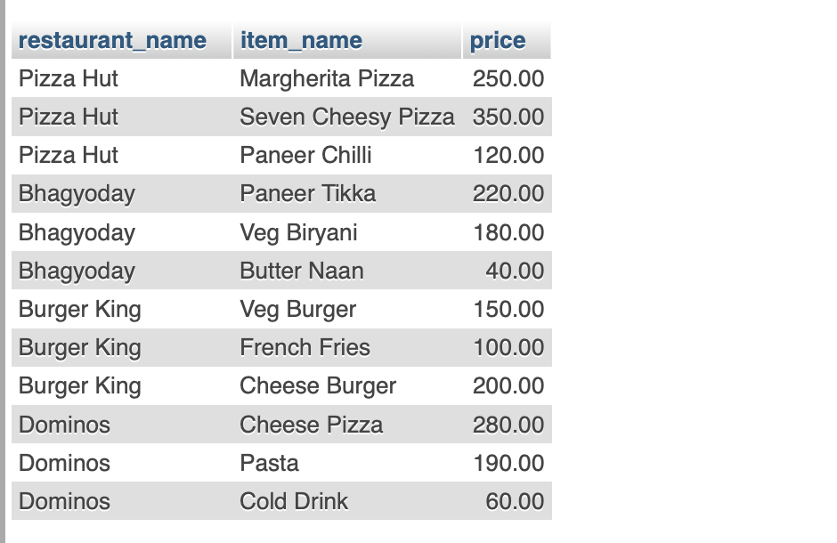

CREATE VIEW restaurant_menu_summary AS
SELECT
r.name AS restaurant_name,
COUNT(m.item_id) AS total_menu_items,
AVG(m.price) AS average_item_price
FROM restaurants r
LEFT JOIN menu_items m
ON r.restaurant_id = m.restaurant_id
GROUP BY r.restaurant_id, r.name;

Select * from restaurant_menu_summary

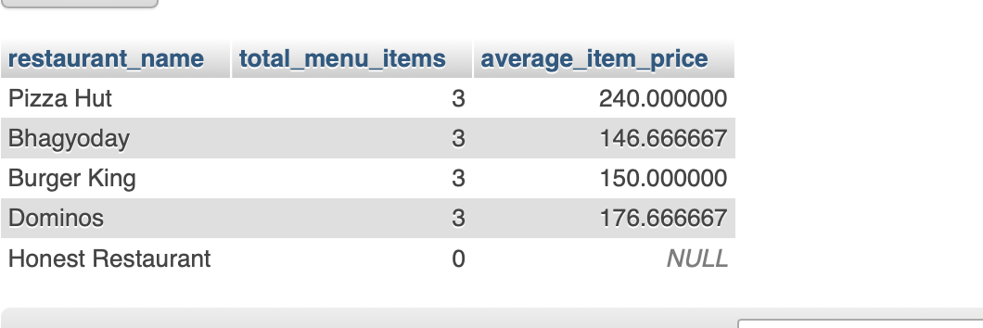

Task 4: PL/SQL Order Placement Procedure Write a stored procedure to process a customer order with wallet deduction and full transaction control. Create a stored procedure named place_order that accepts customer_id, restaurant_id, and amount as parameters. Deduct the amount from the customer's wallet_balance in a customers table and insert a new record into the orders table. Use a transaction block: if the customer's wallet_balance is insufficient, ROLLBACK everything; otherwise COMMIT. Test with a valid order and an order exceeding wallet balance. Screenshot both outcomes from MySQL Workbench.

Answer:

DELIMITER //

CREATE PROCEDURE place_order(
IN p_customer_id INT,
IN p_restaurant_id INT,
IN p_amount DECIMAL(10,2)
)
BEGIN
DECLARE v_balance DECIMAL(10,2);

DECLARE EXIT HANDLER FOR SQLEXCEPTION
BEGIN
ROLLBACK;
RESIGNAL;
END;

START TRANSACTION;

SELECT wallet_balance
INTO v_balance
FROM customers
WHERE customer_id = p_customer_id
FOR UPDATE;

IF v_balance IS NULL THEN
SIGNAL SQLSTATE '45000'
SET MESSAGE_TEXT = 'Customer not found';
END IF;

IF p_amount <= 0 THEN
SIGNAL SQLSTATE '45000'
SET MESSAGE_TEXT = 'Amount must be greater than zero';
END IF;

IF v_balance < p_amount THEN
SIGNAL SQLSTATE '45000'
SET MESSAGE_TEXT = 'Insufficient wallet balance';
END IF;

UPDATE customers
SET wallet_balance = wallet_balance - p_amount
WHERE customer_id = p_customer_id;

INSERT INTO orders
(customer_id, restaurant_id, amount)
VALUES
(p_customer_id, p_restaurant_id, p_amount);

COMMIT;
END //

DELIMITER ;

SELECT * FROM customer WHERE customer_id = 101;
SELECT * FROM orders WHERE customer_id = 101;

